📄 Test Case: TC59_InwardLodgeBill
❌ FAILED:
[2026-03-11 12:04:07] ? Login Failed: User is already logged in.
[2026-03-11 12:04:07] ? Assertion Failure: Finacle Login Error: User is already logged in.
↳ Reason: ❌ ❌ Assertion Failure: Finacle Login Error: User is already logged in.

📸 Screenshot:
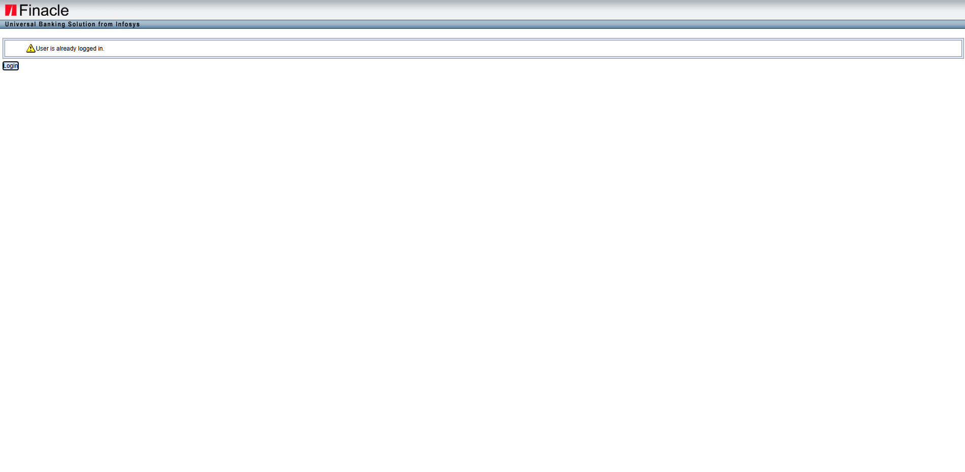
📄 Test Case: TC60_ModifyTheLodgeBillWhichIscreated
❌ FAILED:
[2026-03-11 12:06:21] ? Error: Tenor Details
[2026-03-11 12:06:21] ? Assertion Failure: Test failed: Tenor Details
↳ Reason: ❌ ❌ Assertion Failure: Test failed: Tenor Details

📸 Screenshot:
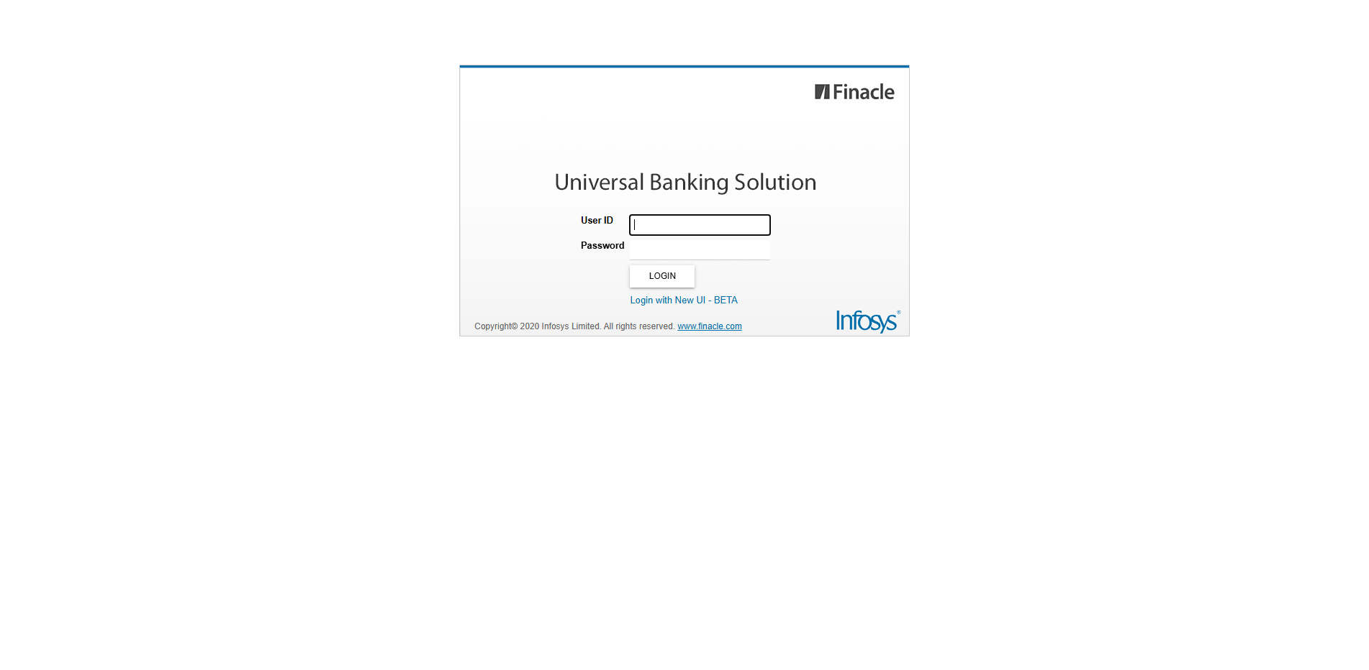
📄 Test Case: TC61_CanceltheModifiedInwardBill
❌ FAILED:
[2026-03-11 12:07:24] ? Login Failed: User is already logged in.
[2026-03-11 12:07:24] ? Assertion Failure: Finacle Login Error: User is already logged in.
↳ Reason: ❌ ❌ Assertion Failure: Finacle Login Error: User is already logged in.

📸 Screenshot:

📄 Test Case: TC62_AmendTheInwardBillWhichIsLodge
❌ FAILED:
[2026-03-11 12:08:20] ? Login Failed: User is already logged in.
[2026-03-11 12:08:20] ? Assertion Failure: Finacle Login Error: User is already logged in.
↳ Reason: ❌ ❌ Assertion Failure: Finacle Login Error: User is already logged in.

📸 Screenshot:

📄 Test Case: TC63_DishonorOfInwardBillWhichIsAmended
❌ FAILED:
[2026-03-11 12:09:26] ? Login Failed: User is already logged in.
[2026-03-11 12:09:26] ? Assertion Failure: Finacle Login Error: User is already logged in.
↳ Reason: ❌ ❌ Assertion Failure: Finacle Login Error: User is already logged in.

📸 Screenshot:

📄 Test Case: TC64_InquireTheInwardBill
❌ FAILED:
[2026-03-11 12:10:25] ? Login Failed: User is already logged in.
[2026-03-11 12:10:25] ? Assertion Failure: Finacle Login Error: User is already logged in.
↳ Reason: ❌ Finacle Login Error: User is already logged in.

📸 Screenshot:

📄 Test Case: TC65_ProtestTheInwardBillWhichIsDishonoured
❌ FAILED:
[2026-03-11 12:11:31] ? Error: E4221 - Liablity Exists, Recovery Event should be performed before Protest.
[2026-03-11 12:11:31] ? Assertion Failure: Test failed: E4221 - Liablity Exists, Recovery Event should be performed before Protest.
↳ Reason: ❌ ❌ Assertion Failure: Test failed: E4221 - Liablity Exists, Recovery Event should be performed before Protest.

📸 Screenshot:

============================================================
📊 Suite Summary: MIIBTests
===============================================
MIIBTests
Total tests run: 7, Passes: 0, Failures: 7, Skips: 0
===============================================
⏱️ Total Duration: 08 min 03 sec

